Internal Structure of Hydra:

1. Body Wall:
The body wall consists of two cellular layers, an outer epidermis derived from ectoderm and an inner gastro dermis derived from endoderm. In between the outer epidermis and inner gastro dermis, a thin non-cellular layer of jelly-like substance called mesogloea is present. Both the epidermis and gastro dermis are composed of different kinds of cells, hence, they are described separately.
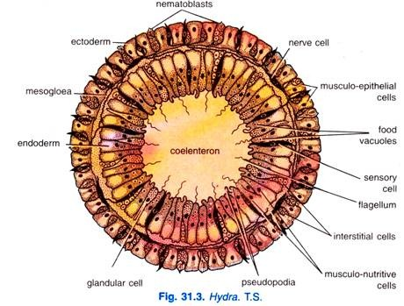

2. Epidermis:
The epidermis is made up of small cubical cells and is covered with a delicate cuticle. It forms a thin layer, about one-third of the thickness of body wall. This layer contains several types of cells-epitheliomuscular, interstitial, gland, cnidoblast, sensory, nerve, and germ cells. The epidermis is protective, muscular and sensory in function.
1. Epitheliomuscular cells:
The epitheliomuscular cells have both epithelial and muscular parts in the same cells.
The epitheliomuscular cells of the epidermis are cylindrical with their inner ends produced into two or more processes which have myonemes or un-striped muscle fibers, these fibers branch and branches anastomose. The ectodermal myonemes run parallel to the long axis of the body and tentacles, they form longitudinal muscles which bring about contraction of the body.:
The epitheliomuscular cell has a large nucleus, and along the border there is a row of granules which secrete the cuticle.
The epidermal cells of the basal disc are granular and they secrete mucus for attachment of Hydra; the basal epidermal cells can also form pseudopodia by which the animal glides on its attachment. Some granular epidermal cells of the basal disc secrete a gas to form a bubble by which the Hydra breaks from its attachment and is lifted up.
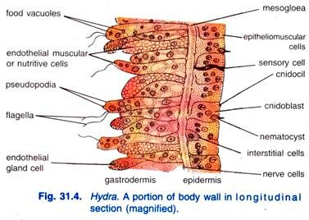
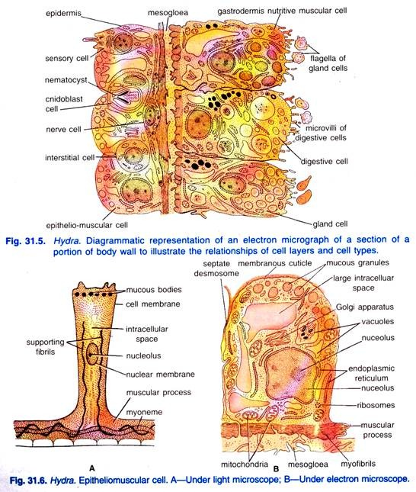
Functions:
The epitheliomuscular cells perform the following functions:
1. They form a protective covering of the body;
2. They help in contraction, shortening and bending of body;
3. They help in locomotion;
4. They help in attachment with the solid object, and
5. They help in respiration through mucous layer at the cell surface.
2. Interstitial Cells:
Lying in the spaces between the inner ends of cells of epidermis and between outer ends of cells of gastro dermis are interstitial cells (Fig. 31.6) lying in groups.
These are small, oval or round cells with a large nucleus. Interstitial cells form a growth zone just below the tentacles, from this zone all kinds of new cells arise which push out the old worn out cells, which are shed at the proximal and distal ends.
Interstitial cells form nematocysts and germ cells, they can also form epitheliomuscular cells, they renew all cells of the animal once every 45 days (Brein, 1955), thus, they are totipotent.
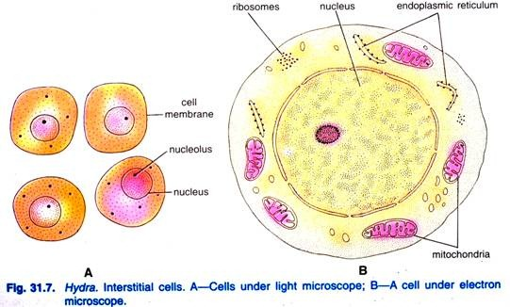
Functions:
The interstitial cells perform the following functions:
1. These cells are the main agent in rebuilding tissues during growth, budding and regeneration;
2. They form gonads during breeding season to give rise to germ cells;
3. They reform the worn out cells of gastro dermis and also differentiate to form new nematocysts to replace to older and worn out ones.
3. Gland Cells:
These are tall cells found chiefly on the pedal disc and around the mouth region. They produce a secretion by which the animal can attach itself and sometimes a gas bubble by which the animals can rise and fasten on to the surface of the water to float.
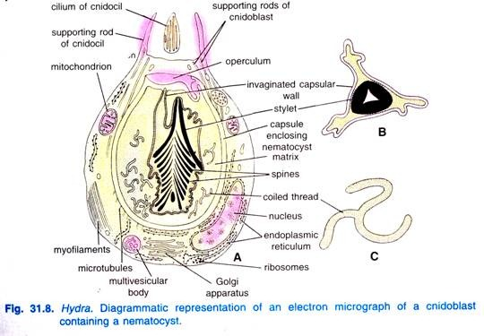
4. Cnidoblasts:
Cnidoblasts (Gr., knide = nettle; blastos = germ) are found throughout the epidermis but specially on the tentacles.
Some interstitial cells of the epidermis give rise to highly specialised cells called cnidoblasts. These are somewhat oval-shaped cells, contain the cell organoid, the nematocyst (Gr., nema = thread; kystis = bladder) or stinging cell. The nematocyst is made up of rounded capsule which encloses a coiled tube or thread that is continuous with the capsular wall to which it is attached.
Nematocyst:
A nematocyst is not a cell because it is chitinous and non-living. A clear space arises in the cnidoblast, the space grows and the cell secretes a double-walled chitinous capsule which has a lid or operculum. One end of the capsule forms a tube lying coiled in the capsule, the tube may have a basal swelling called a butt, and a long coiled thread which may be open or closed at the tip, inside the tube may be some spines.
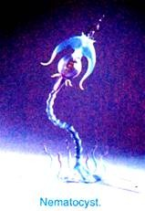
This structure secreted by a cnidoblast is a nematocyst. In the nematocyst is a poisonous toxin made of mixture of proteins and phenols.
On the wall of the capsule are contractile fibrils running into the cnidoblast. In some nematocysts, the cytoplasm of the cnidoblast forms contractile muscle fibrils. Some nematocysts have a lasso or restraining thread attached to the base of the cnidoblast, the lasso prevents certain nematocyst from being thrown out of the body of an animal.
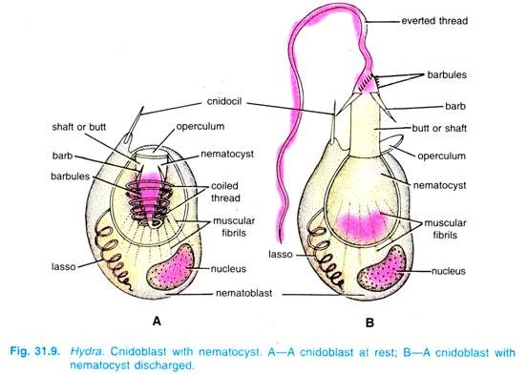
Nematocysts are produced only on the stomach, cnidoblasts containing developing nematocysts migrate through the body wall or into the enteron from where they are taken up by pseudopodia of endoderm cells and transferred to mesogloea through which they travel and penetrate outwards again through the body wall to reach their ultimate positions where development is completed; the cnidoblast gets fixed in the ectoderm with its base reaching the mesogloea, the cnidocil bores through the cuticle and projects outside.
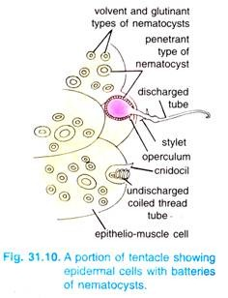
Hydra has four kinds of nematocysts confined to the ectoderm:
1. Penetrants or stenoteles:
Penetrants or stenoteles have a large capsule, the butt is stout with their spiral rows of spines on its distal half, the lowest spine of each row is a large stylet; the thread had spirals of small spines and it is open at the tip. Stenoteles are weapons of defence and offence, their thread penetrates the body of the prey, they are also used for obtaining food.
2. Desmonemes or volvents:
Desmonemes or volvents have a small oval capsule, there is no butt, the thread is thick with no spines and it is closed at the tip, it lies in a single loop inside the capsule. On being discharged, the volvents are thrown out of the body and the thread coils around the bristles of the prey; they are used for obtaining food.
3. Small glutinants or atrichous isorhizas:
Small glutinants or atrichous isorhizas have an elongated capsule, butt is absent, thread is open at the tip, and it has no spines, they fix the tentacles to an object when the animal walks on its tentacles.
4. Large glutinants or holotrichous isorhizas:
Large glutinants or holotrichous isorhizas have an oval capsule, the butt is narrow and the thread is open at the tip, there are small spines on the butt and thread. Their function is doubtful but they stick to the surface of the prey.
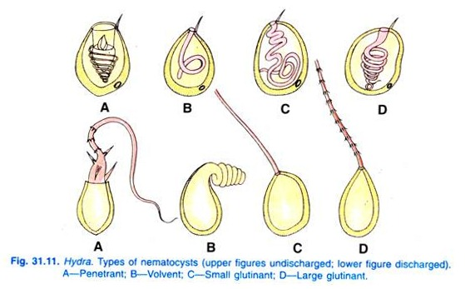
Distribution of nematocysts:
Nematocysts are plentiful on the tentacles and body, but they are absent from the basal disc. All four kinds of nematocysts are found on the tentacles in abundance, hypostome has only holotrichous isorhizas, the body has mostly stenoteles and some holotrichous isorhizas.
Discharge of nematocysts:
Nematocysts are discharged but once, after discharge they are cast off, though volvents are thrown out being discharged, new nematocysts are found all the time. The method of discharge of nematocysts is not clear, but they are not under the control of the nervous system, hence, they are independent effectors, they are functional even in the bodies of some other animals.
An anaesthetized Hydra will discharge its nematocysts in the usual way when stimulated; even nematocysts removed from the body will shoot out their thread if an adequate stimulus is applied to them. Some animals swimming near a Hydra will cause the nematocysts to discharge, yet some other animals can walk on the body of Hydra without discharging the nematocysts.
Functions:
The cnidoblasts are supposed to be the organ of offence and defence of Hydra. They also help in the function of food-capture, locomotion and anchoring with the substratum.
5. Sensory Cells:
They are long narrow cells with a large nucleus and one projecting flagellum or sensory hair, their base may be produced into nodulated processes which join the nervous system. Sensory cells are found in both germinal layers, but they are more abundant in the ectoderm, they are sensory to touch, light, temperature changes and chemicals.
A sensory cell acts both as a receptor and as a sensory neuron, that is, it both receives and transmits impulses. The tentacles are devoid of gland cells and sensory cells, and their endoderm cells have no muscle processes.
6. Nerve Cells or Ganglion Cells:
The nerve cells or ganglion cells are small and elongated having one or more processes. They are situated at the base of the epitheliomuscular cells just above their muscular processes. They are rarely found in gastro dermis.
7. Neurosecretory Cells:
The neurosecretory cells (Fig. 31.12D) are named on the basis of their membrane bound dense granules. They are deeply situated and contain a cilium that extends towards the surface. The cilium arises from the base of an indentation of the plasma membrane. Finger-like projections extend into the space produced by the indentation but the projections do not reach the base of the indentation.
The projections surround the cilium. Below the cilium, striated rootlets extend for a considerable distance into the cytoplasm. The neurosecretory cells are identical to nerve cells except for numerous membrane bound granules. These granules are 1000 to 1200 A° in diameter and present in the cytoplasm in close approximation to be within the dilated ends of Golgi apparatus lamellae.

8. Germ Cells:
Germ cells originate by the repeated divisions of the interstitial cells in certain restricted regions of the body of Hydra during the summer. These form the gonads which later differentiate either into testes or ovaries.

3. Gastrodermis:
The inner gastro dermis, a layer of cells lining the coelenteron has a plan similar to the epidermis. It is made up chiefly of large columnar epithelial cells with irregular flat bases. The free ends of the cells give a jagged and uneven contour to the coelenteron in cross section.
The gastro dermis forms about two-thirds of the body wall and is secretory, digestive, muscular and sensory. The cells of gastro dermis include nutritive muscular, interstitial and gland cells.
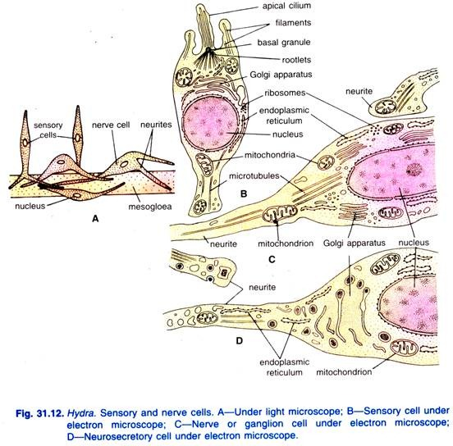
1. Nutritive muscular or digestive cells:
The epitheliomuscular cells of gastro dermis are long and club-shaped, their outer ends have two processes containing a myoneme which does not branch; these myonemes lie at right angles to the long axis of the body, they form circular muscle layer by which the animal contracts and slowly expands the body.
Some of them serve as sphincters to close the mouth and cavities of tentacles because the gastro dermal myonemes are best developed in the hypostome and in the bases of tentacles.
The cells are highly vacuolated and often filled with food vacuoles. The free end of the cell usually bears two flagella. Gastro dermal cells in the green hydra (Chlorohydra) bear green algae (Zoochlorella) which give the hydra their colour. Nutritive muscular cells may also secrete digestive enzymes into the coelenteron for the digestion of foods.
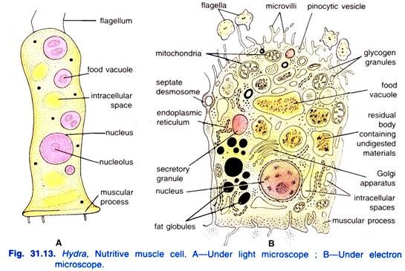
Circularly oriented muscular processes containing myofilaments lie above mesogloea. Each cell bears a pair of flagella which are typical in structure, that is, each flagellum consists of nine peripheral and two central fibres enclosed in a sheath.
Digestive cells of tentacles are pyramidal in shape and contain a large intracellular space surrounded by a thin rim of cytoplasm in which lipid droplets and food vacuoles are found. Free microvilli and pinocytotic vesicles are present. The digestive cells of hypostome are irregular in shape, between the bases of these are found numerous gland cells.
2. Interstitial cells:
There are a few of these small cells scattered among the bases of nutritive cells. They may transform into other types of cells when the need arises, i.e., totipotent in nature.
3. Gland cells:
Gland cells are often club-shaped, with the larger end facing the coelenteron. They are interspersed singly between the digestive cells. Most are club-shaped tapering to a narrow base which extends towards the mesogloea but do not reach it.
Gland cells are of two kinds, viz.,:
(i) Mucous gland cells are found in the mouth and hypostome, they secrete mucus which helps in swallowing solid food,
(ii) Enzymatic gland cells are found in the stomach where they secrete digestive enzymes. The gastro dermis of the stalk and tentacles is devoid of gland cells. Gland cells pour their secretions into the coelenteron for extracellular digestion. Gland cells are not under the control of the nervous system, they are independent effectors.
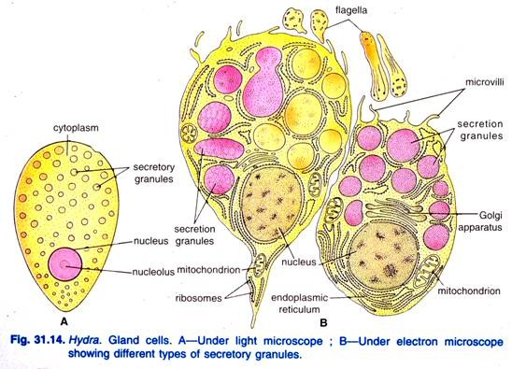
Gland cells are most abundant in the hypostome, numerous in stomach and budding zone, rare in peduncle and virtually absent in tentacles and base. The cells develop from interstitial cells most frequently in growth region but very little is known about the replacement of all gland cells exhausted during secretion.

4. Mesogloea:
The mesogloea (Gr., meso = middle; glea = glue) lies between the epidermis and gastro dermis and is attached to both layers. It is gelatinous or jelly-like and has no fibres or cellular elements. It is a continuous layer which extends over both body and tentacles, thickest in the stalk portion and thinnest on the tentacles.
This arrangement allows the pedal region to withstand great mechanical strain and gives the tentacles more flexibility. The mesogloea supports and gives rigidity to the body, acting as a sort of elastic skeleton.

5. Gastro vascular cavity:
The L.S. (Fig. 31.2) and T.S. (Fig. 31.3) of Hydra shows a central cavity in its body called coelenteron (= hollow gut) functionally referred to as gastro vascular cavity. Mouth opens in this cavity and there is no other exit in it. However, this cavity remains continuous in the tentacles and, therefore, the tentacles are hollow. The gastro vascular cavity is the site of digestion and circulation.
